Knee Stretches and Exercises

Below are stretches and Massages you can do to help knee pain. Use a lacrosse ball or a foam roller (or both) when doing these. Prioritize the “Smashing” and rolling techniques first. Do each for approx. 5mins.

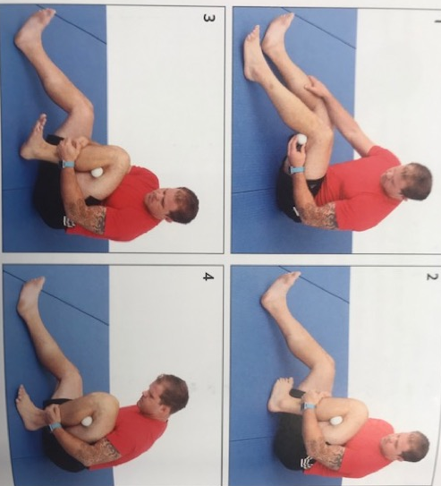
Place Lax Ball behind knee on inside of your leg.

Curl your heel towards butt and use both hands to pull leg in tight

While pulling with hands move your foot around in all directions

To increase pressure plant our foot on the ground and scoot butt towards your heel.

Same as above but place the lax ball on the inside on leg behind the knee.
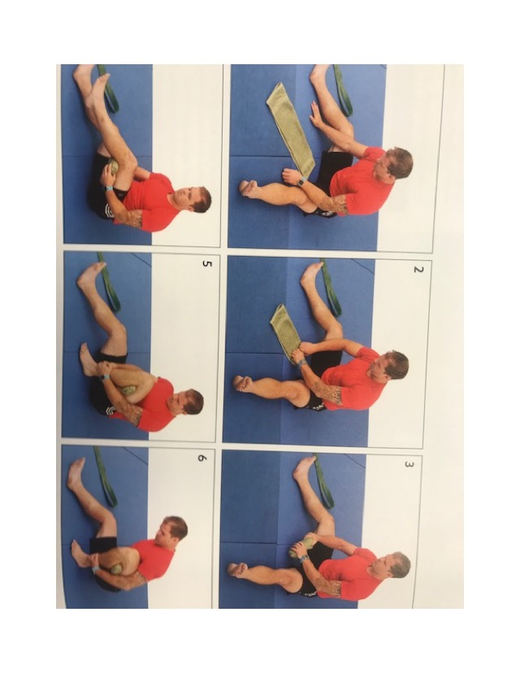
Roll up small town and place it behind knee.

Grab your shin and pull it towards you and scoot your butt towards your foot.

Try to keep foot straight

These are additional stretches and exercises you can do. Confused with any? Ask a coach or google them.

Air Squats 3 x 15 (Keep back straight “Slide down a wall”)
Clams 3 x 15 Each Leg
Front Leg Raises 3 x 15 Each Leg
Back Leg Raises 3 x 15 Each Leg
Side Leg Raise 3 x 15 Each Leg
Scorpions 3 x 15
Iron Cross 3 x 15
Stretching – Butterfly, Hollywood (Both Legs) and Standing Cross-overs (both Legs) – 2 x 30 sec each.
Ice for 12mins

Things to keep in mind…
The most common cause for Knee pain is weakness in the hips, quads, and Pelvis. Strengthening this area will lead to less pain in the knee.

Forefoot striking instead of heel striking can lead to less stress on the knee

How old are your shoes? More than 6 months? It might be time to get new shoes.

